Order Management System

**Capgemini India**

Agraj Naman

PLP Documentation

SFDC Batch : 2 Hinjewadi, Pune



**Abstract :**

Order Management System is an application which automates all the hassle of creating order invoices and Individual product invoices at sales level of a company. It’s deployed over salesforce.com. The accessibility to the application is divided over 3 types of company associates named: **Support User**,  **Business User** and **Sales User**. The Sales User are the customer end of the chain. They take Orders with the customers(**Accounts**) who have an existing **Contract.** Once an Order is Placed the system auto validates the requirements and Changes the Order Stage accordingly. While changing order stage the Account’s contact will be getting constant communication through mail. The system will create the Invoices and Product Invoices of the entire transaction filled with the billing details. The accessibility is divided to the users as per the project demand and approval process is automated as well.

**Scopes :**

**InScopes :**

Following functionalities are provided by the system.

There are 3 category of the User who can access the system :

1. **Sales User**  : *Characteristics*  --- >
   1. This is the only class of user that can create the Orders but cannot delete them.
   2. They can view their order records.
   3. They can create contract but cannot delete them.
   4. They can create Accounts but cannot delete them.
   5. Each Sales User is managed by a Business User.
   6. Can view the Auto-generated Invoice and Auto-generated Product Invoice
2. **Business User** : *Characteristics*  --- >
   1. This class can only view : Orders, Contract , Account , Invoice , Product Invoice of its managed sales user only.
   2. They are the approver of the approval process called from there managed sales user profile.
3. **Support User** : *Characteristics*  --- >
   1. They are more like Administrator of the entire application. They have read and write permission over all the standard and custom objects.
   2. They monitor the entire statistics through reports and dashboard.

**Out Scopes :**

Following functionalities are not covered in the application :

1. Application cannot track beyond the ‘ Invoice Generated ’ order stage.
2. Application cannot track delivery info.
3. Payment are not accepted by application.

**UML DIAGRAMS**

* Class Diagram

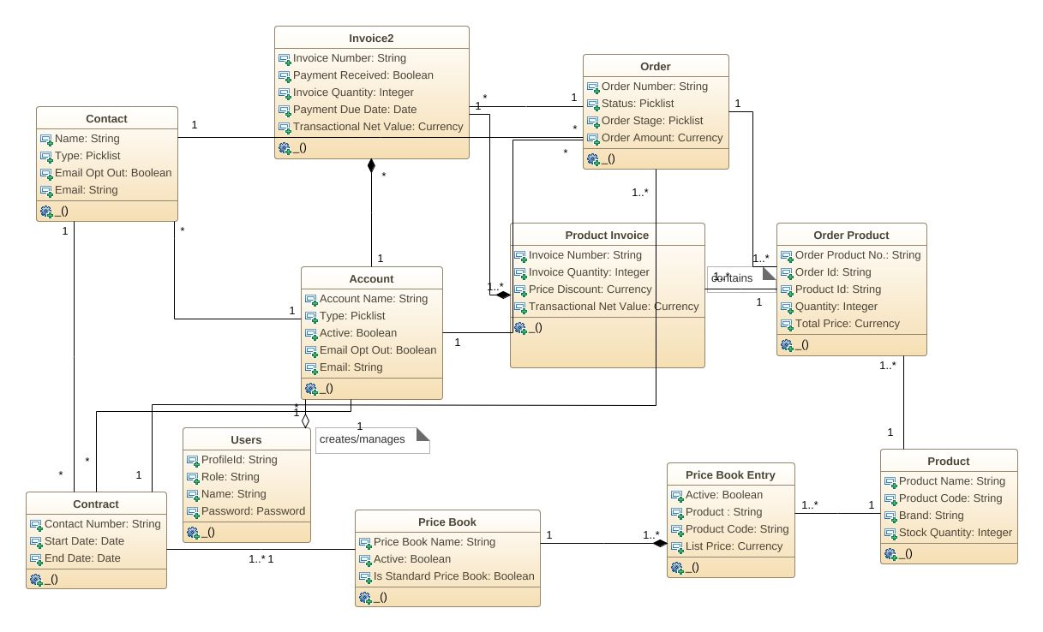

* 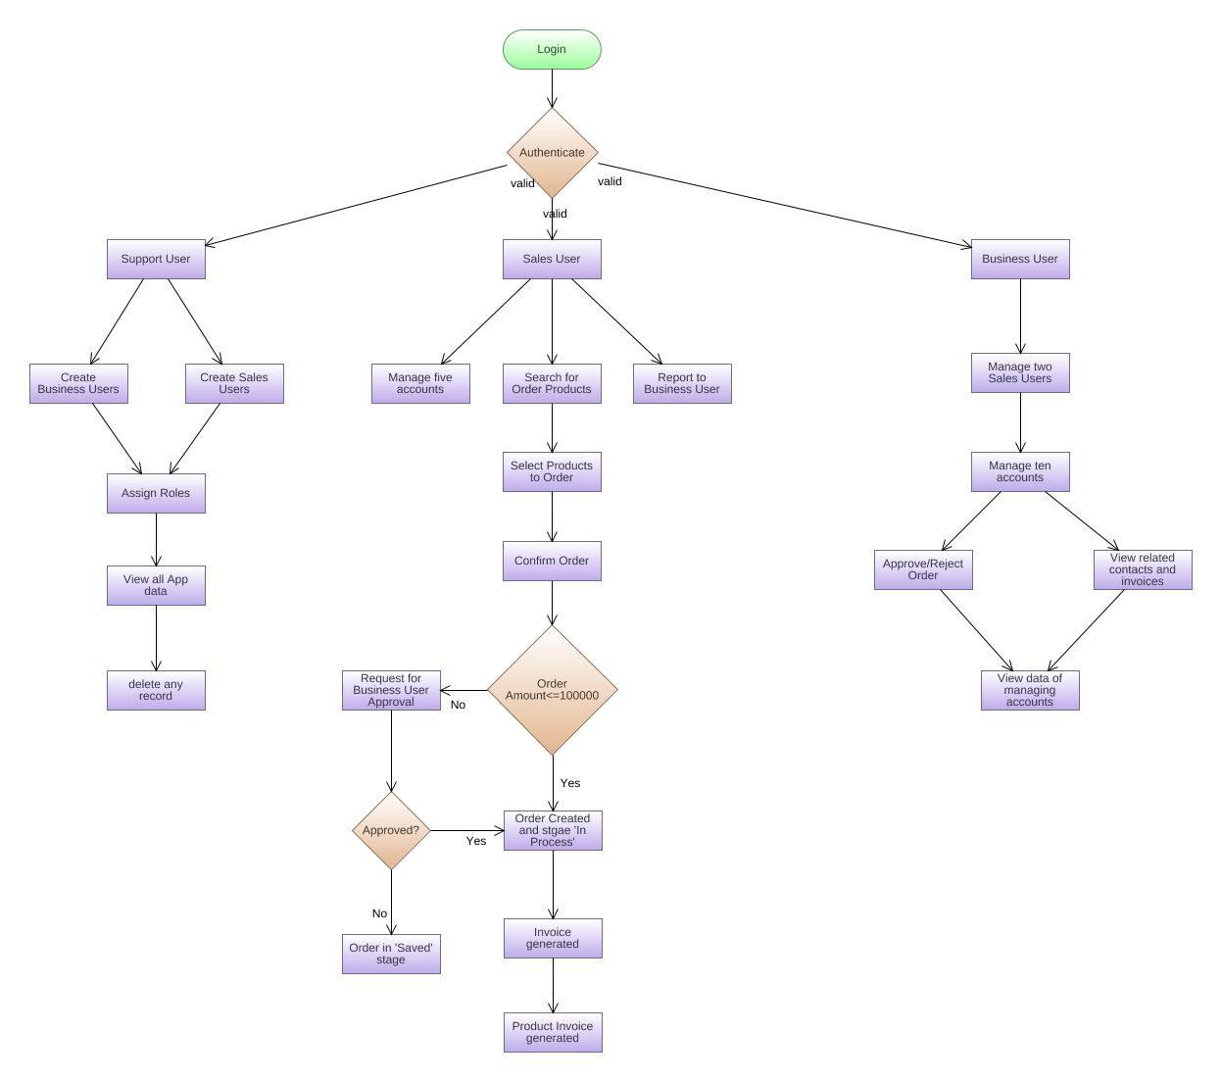Flow Chart
* Sequence Diagram

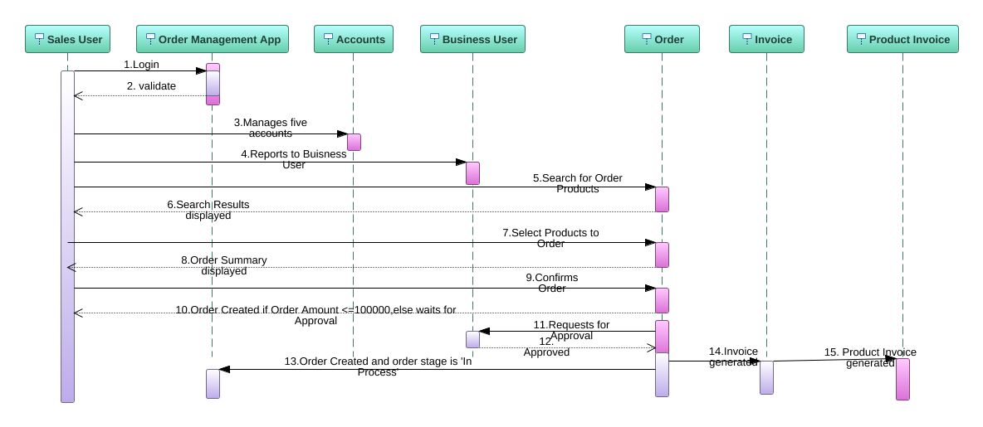

* Usecase Diagram

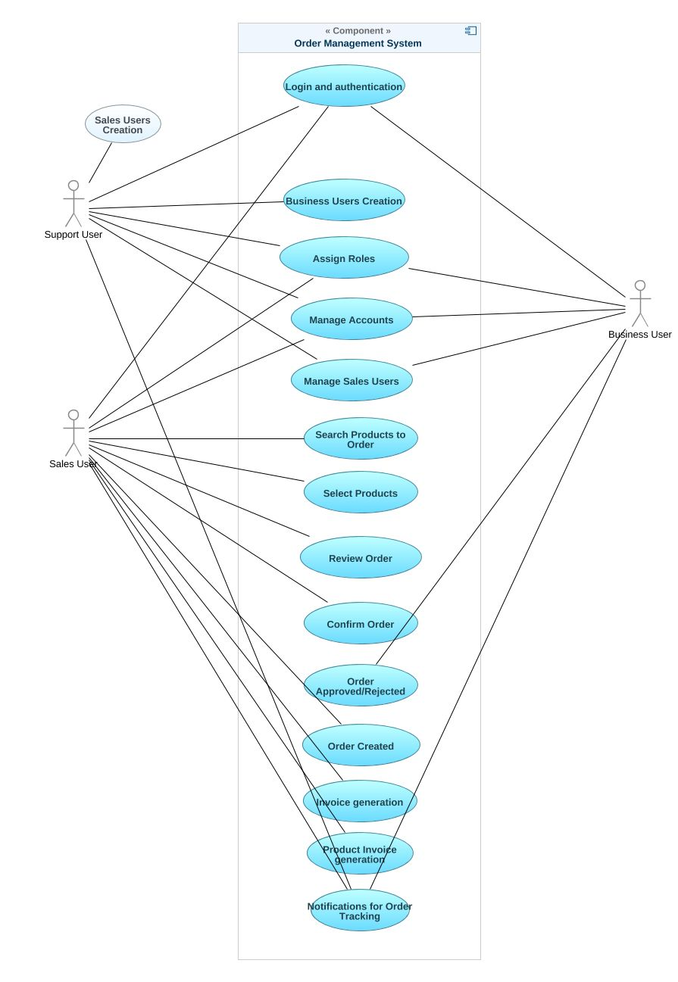

* Activity Diagram

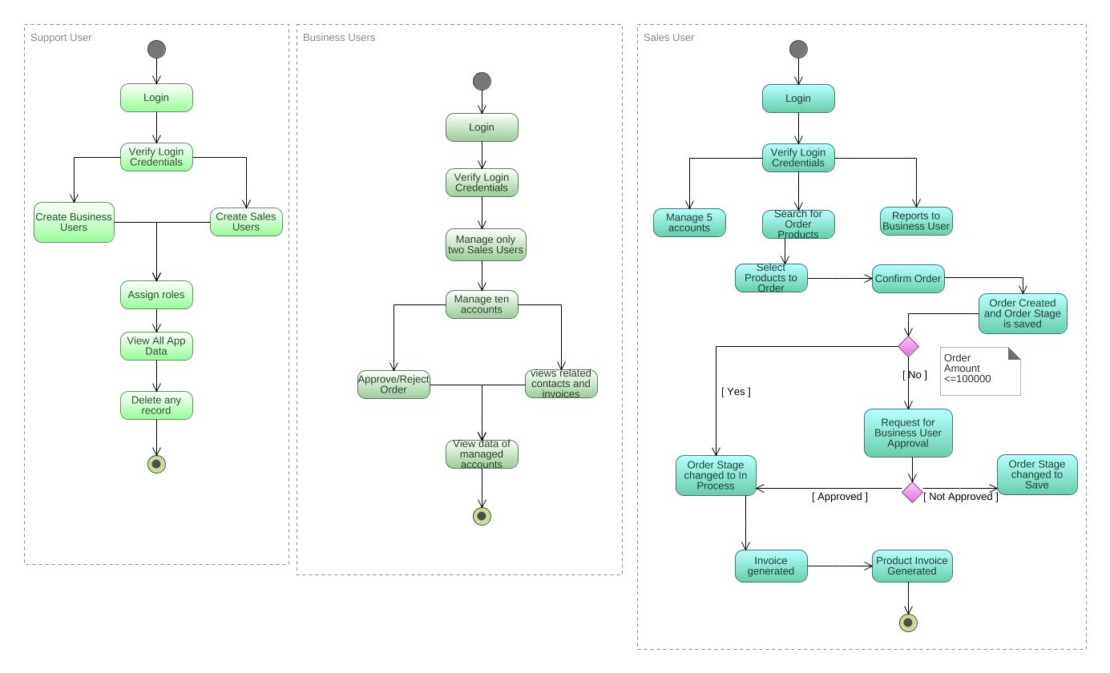

**User Interface while walkthrough the application :**

Click on Application in the App launcher :

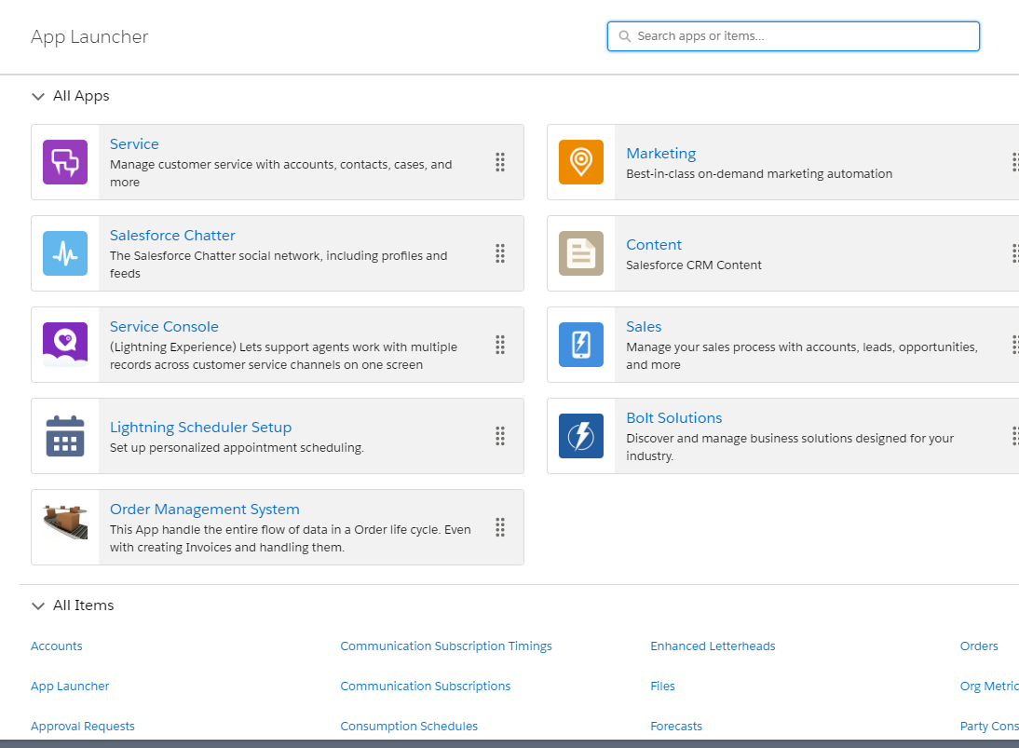

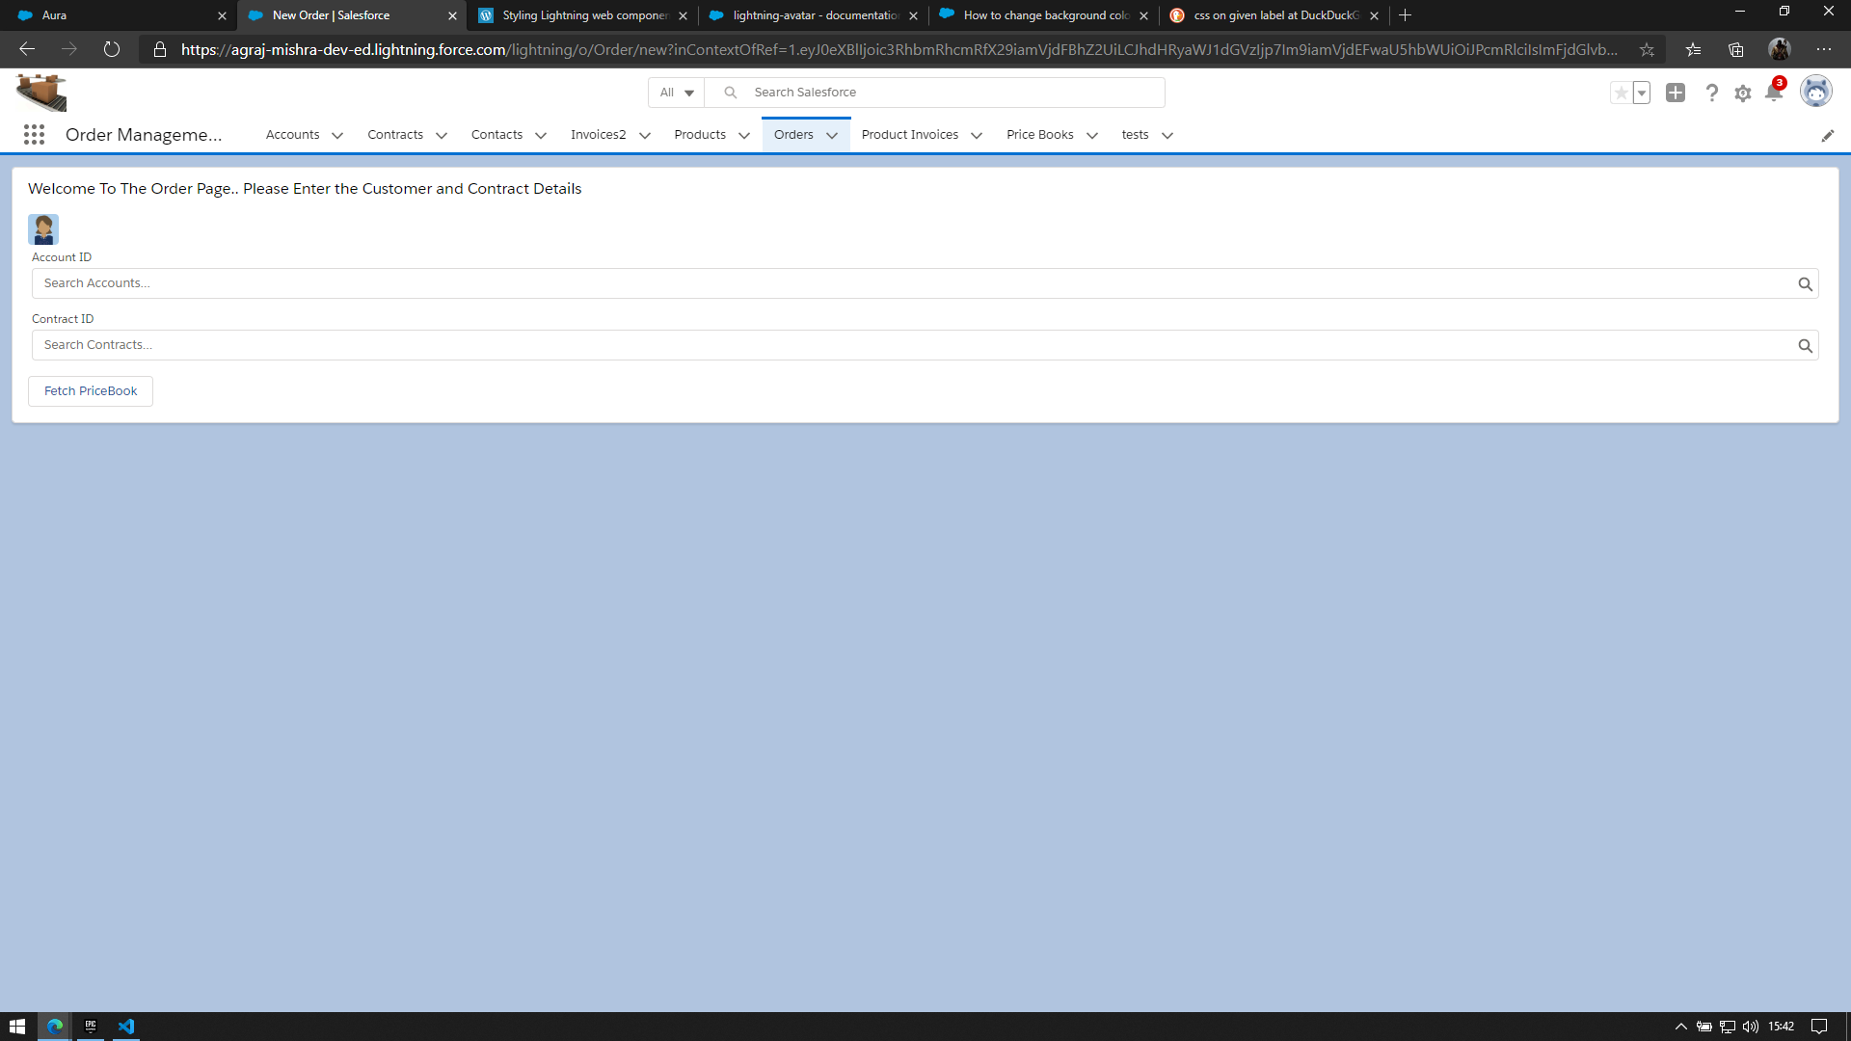Go to Order Object and Click ‘**New**’ to see the LWC Order Page and Browse the existing Account and contract from the lookup field :

Select the Search criteria and enter the search Query : add the product by clicking on ‘Add Item’.

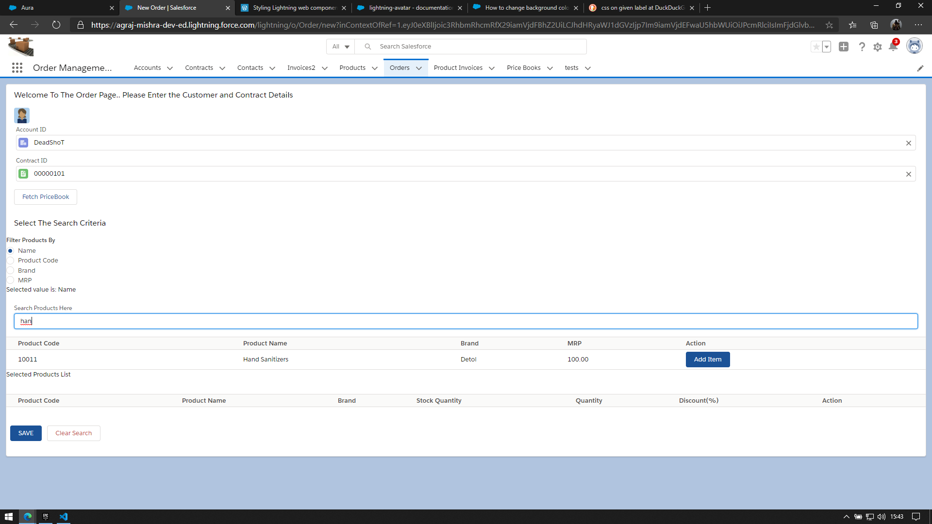

Select the required quantity : Click **Remove** if you don’t need it Or click **Clear search** to clear the entire selected product list. Click **save** to preview the order.

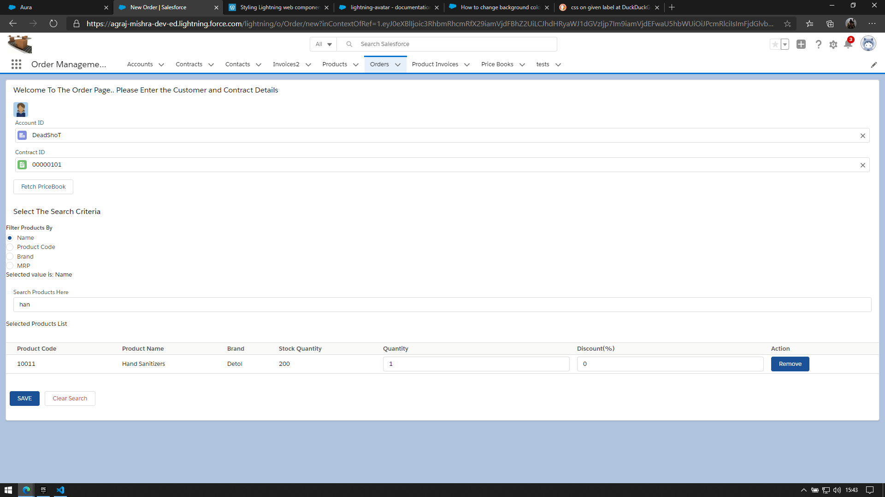

Order Priview screen :

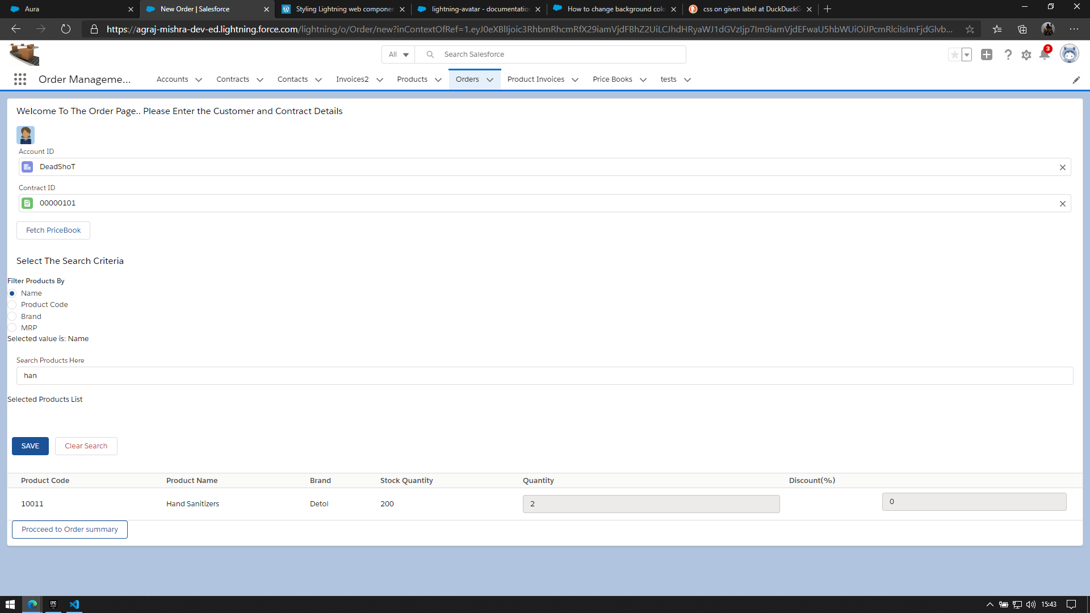

Order Summary Page : Can change the order.

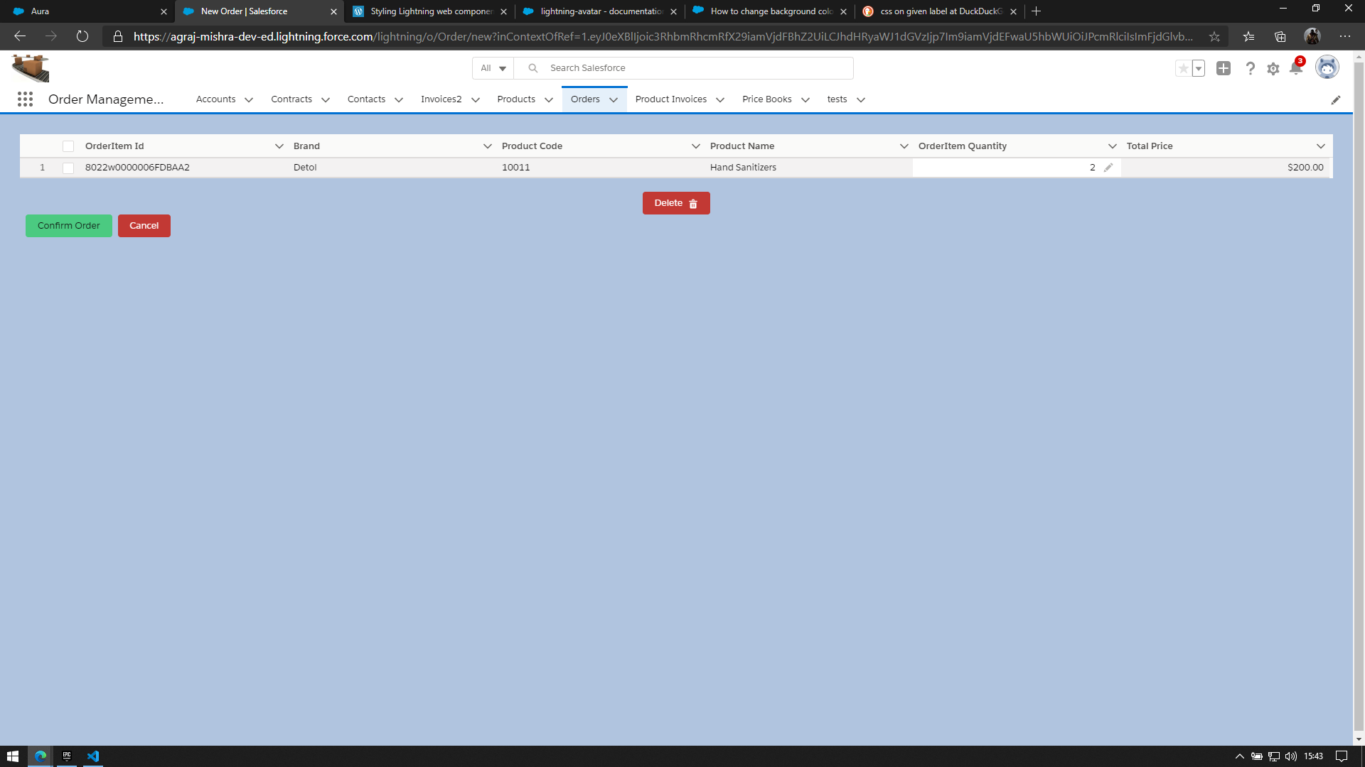 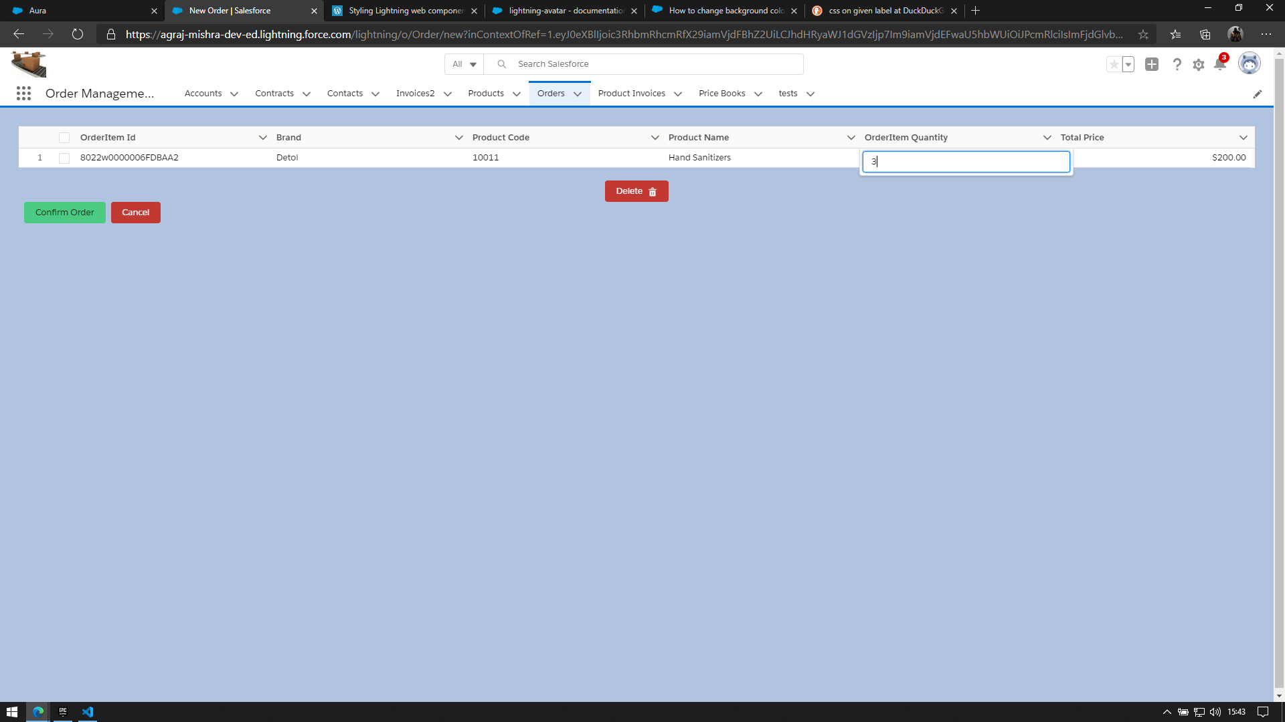 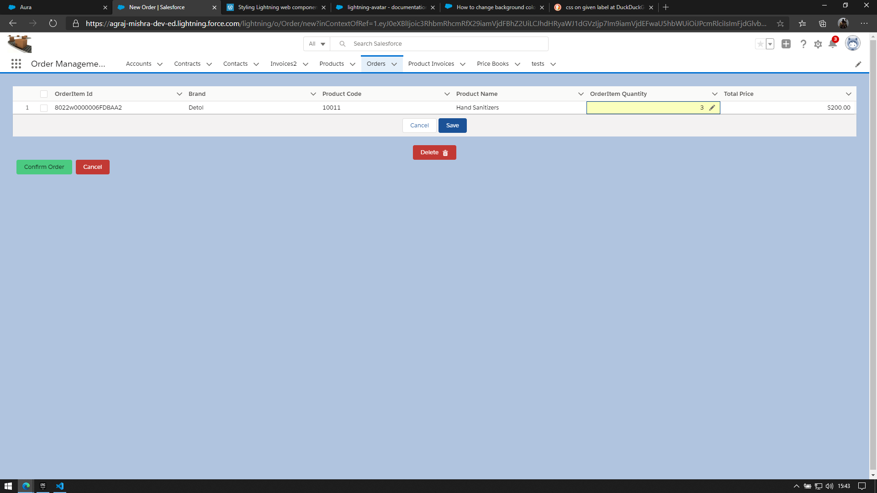 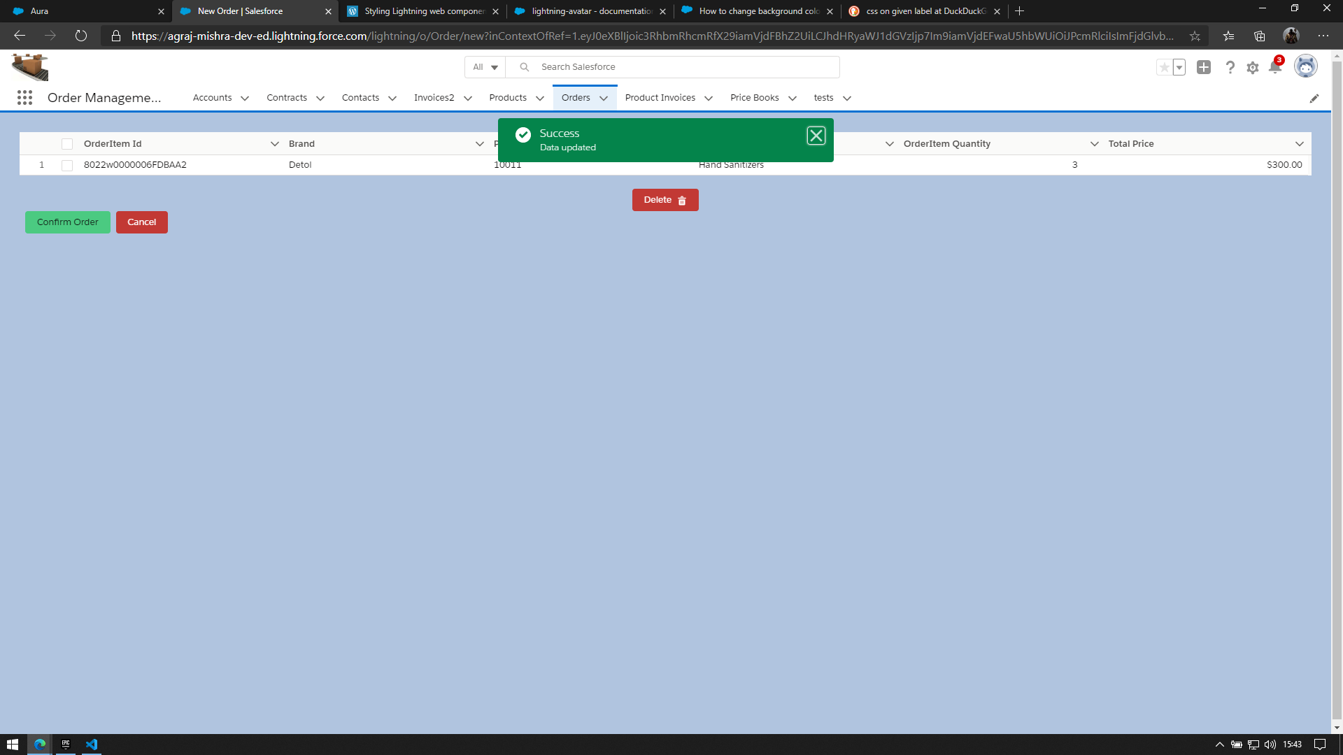 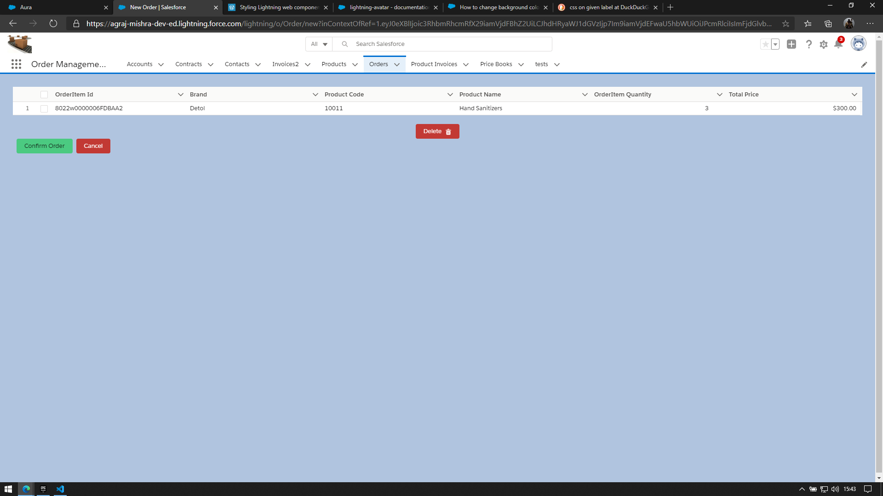

Note if you press cancel now then a prompt will ask you for remark as shown in the picture below and it will be stored in the order remark field with stage as cancelled.

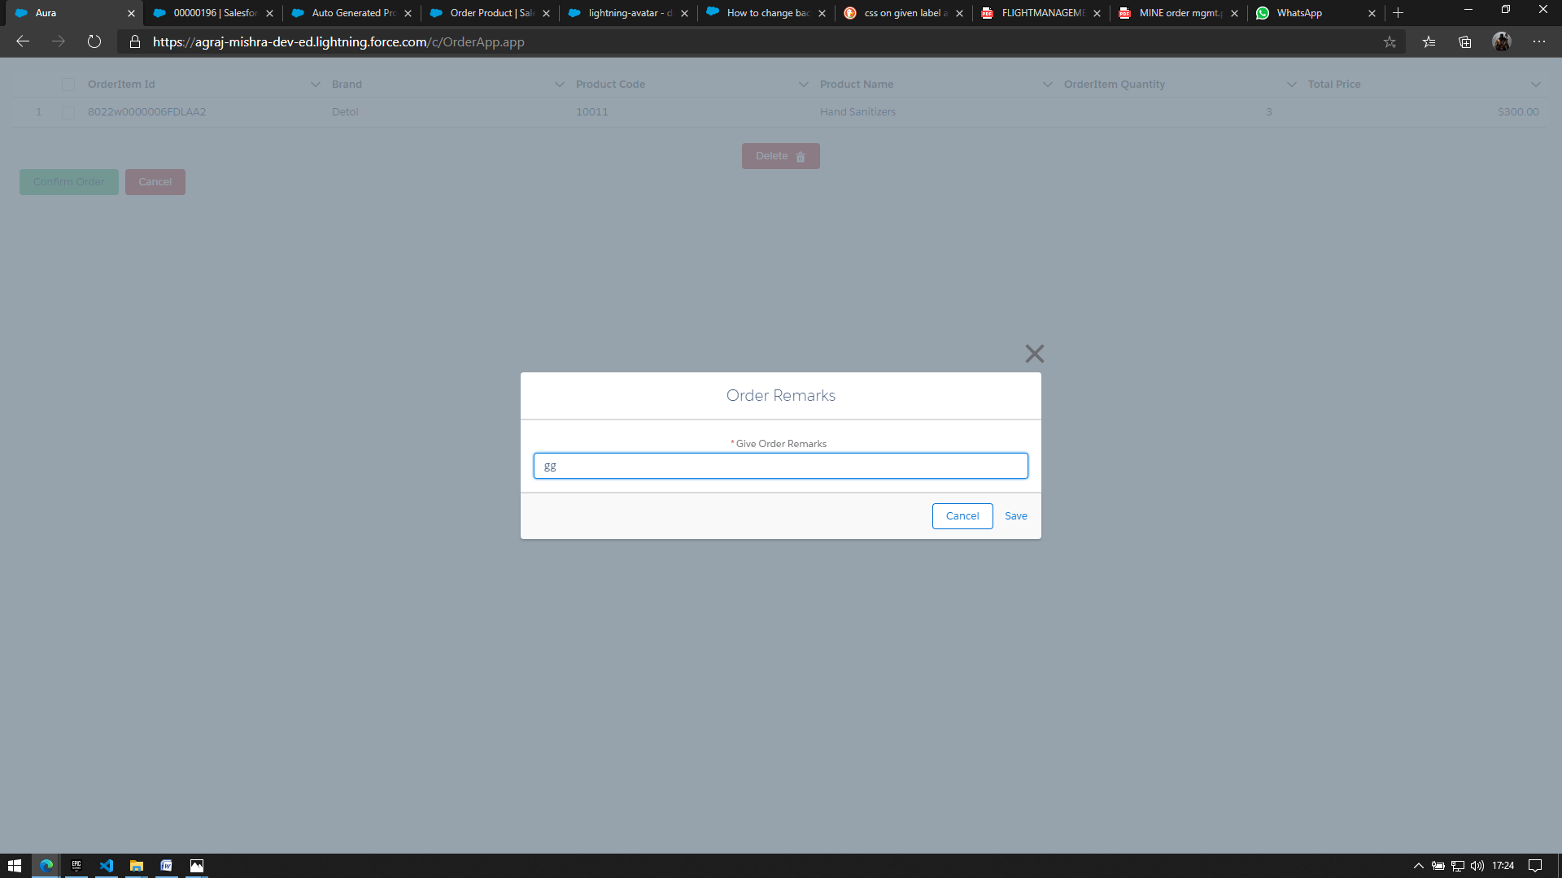

Order Detail page : invoice generated automatically (as shown in the picture)

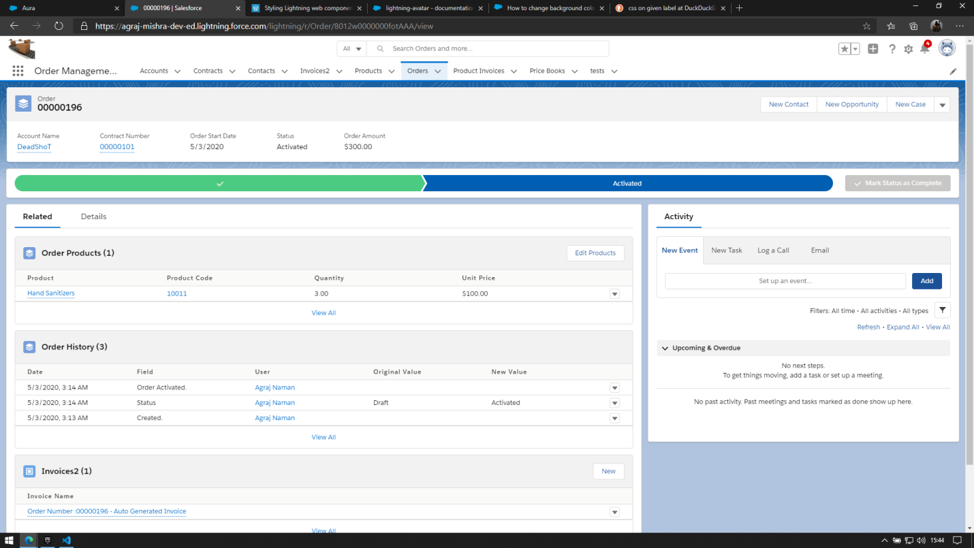

With the given status at the Order remark field and Order stage as cancelled :

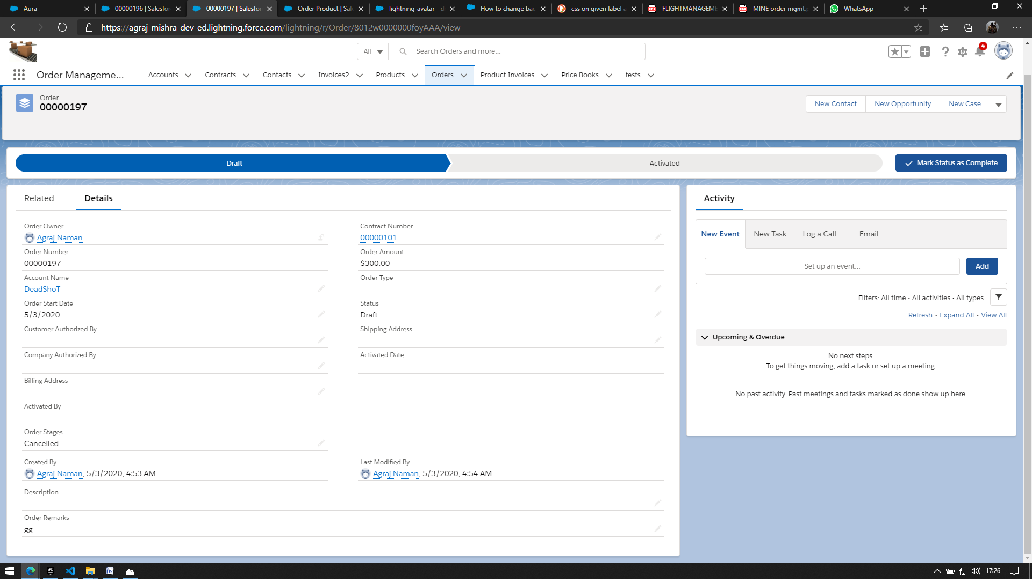

Autogenerated Invoices and Product Invoices : (With all required fields)

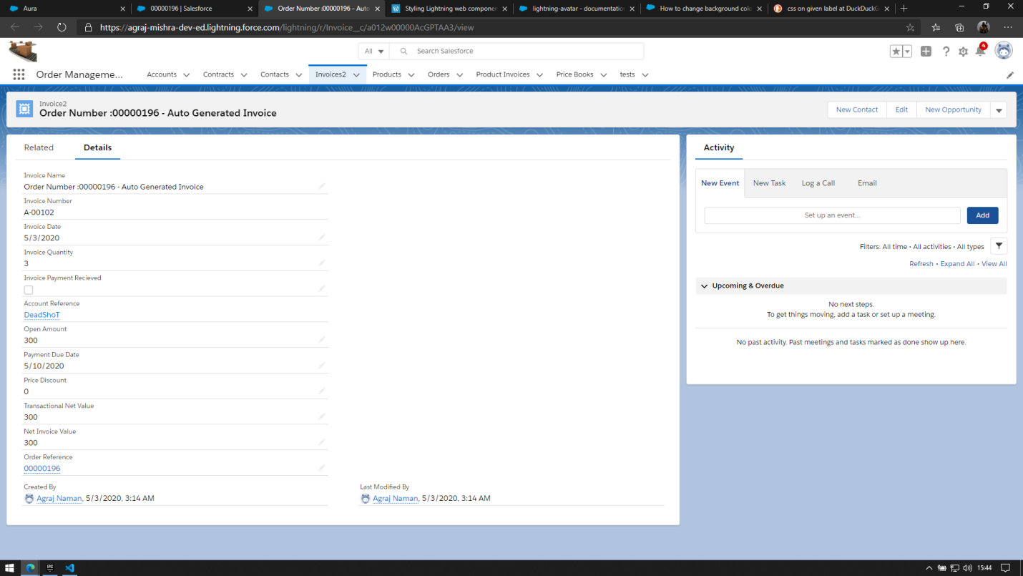

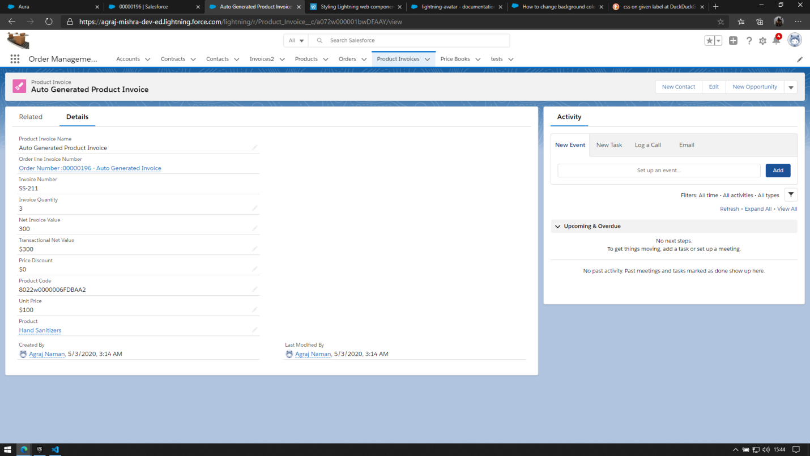

**Objects and Problem Approach Description**

Objects Involve in this project are :

* Standard Objects :
  + Account

Represents an individual account, which is an organization or person involved with your business (such as customers, competitors, and partners).

Fields

* + - AccountNumber: Account number assigned to this account.
    - AccountSource: The source of the account record. For example, Advertisement, Data.com, or Trade Show.
    - AnnualRevenue: Estimated annual revenue of the account.
    - Industry: An industry associated with this account. Maximum size is 40 characters.
    - Name: Name of the account.
    - NumberOfEmployees: Number of employees working at the company represented by this account.
    - OwnerId: The ID of the user who currently owns this account. Default value is the user logged in to the API to perform the create.
  + Contact

Represents a contact, which is a person associated with an account. In Salesforce ,we store information about our customers using accounts and contacts. Accounts are companies that we are doing business with , and contacts are the people who work for those companies.

Fields

* + - AccountId: ID of the account that’s the parent of this contact.
    - Email: The contact’s email address FirstName: The contact’s first name up to 40 characters.
    - Title: Title of the contact, such as CEO or Vice President.
    - Department: The contact’s department.
  + Contract

Represents a contract (a business agreement) associated with an Account.

Fields

* + - AccountId: Required. ID of the Account associated with this contract.
    - ActivatedById: ID of the User who activated this contract.
    - ActivatedDate: Date and time when this contract was activated.
    - CompanySignedDate: Date on which the contract was signed by your organization.
    - CompanySignedId: ID of the User who signed the contract.
    - ContractNumber: Number of the contract.
    - ContractTerm: Number of months that the contract is valid.
    - Pricebook2Id: ID of the pricebook, if any, associated with this contract.
  + Order

Represents an order associated with a contract or an account.

Fields

* + - AccountId: Required. ID of the Account associated with this order.
    - ActivatedById: ID of the User who activated this order.
    - ActivatedDate: Date and time when the order was activated.
    - BillToContactId: ID of the contact that the order is billed to.
    - ContractId: ID of the contract associated with this order.
    - OpportunityId: ID for the opportunity that’s associated with this order.
    - OrderedDate: The date and time that the order was placed.
    - OrderNumber: Order number assigned to this order .
    - OwnerId: Required. ID of the User or queue that owns this order.
    - Pricebook2Id: Required. ID of the price book associated with this order.
    - TotalAmount: The total amount for the order products associated with this order.
    - Order Stage: The current stage of the order.
  + OrderItem

Represents an order product that your organization sells.

Fields

* + - AvailableQuantity: Amount of an order product that is available to be reduced.
    - ListPrice: List price for the order product. Value is inherited from the associated PriceBookEntry upon order product creation.
    - OrderId: ID of the order that this order product is a child of.
    - OrderItemNumber: Automatically generated number that identifies the order product.
    - Product2Id: ID of the Product2 associated with this OrderItem.
    - Quantity: Number of units of this order product.
    - TotalPrice: Total price for this order product.
    - Default Value: TotalPrice = (UnitPrice * Quantity) UnitPrice: Unit price for the order product.
  + Product2

Represents a product that your org sells.

Fields

* + - Family: Name of the product family associated with this record.
    - IsActive: Indicates whether this record is active (true) or not (false). Inactive Product2 records are hidden in many areas in the user interface.
    - Name: Required. Default name of this record. Label is Product Name.
    - ProductCode: Default product code for this record.
    - Brand: The brand of the product.
    - Stock Quantity: The quantity of product available for selling.
  + Pricebook2

Represents a price book that contains the list of products that your org sells.

Fields

* + - Description: Text description of the price book.
    - IsActive: Indicates whether the price book is active (true) or not (false). Inactive price books are hidden in many areas in the user interface.
    - IsStandard: Indicates whether the price book is the standard price book for the org (true) or not (false). Every org has one standard price book—all other price books are custom price books.
    - Name: Required. Name of this object. This field is read-only for the standard price book. Label is Price Book Name.
  + Price book Entry

A price book entry defines the price for which you sell a product at a particular currency. Fields

* + - IsActive: Indicates whether the price book entry is active (true) or not (false).
    - Pricebook2Id : Id of the associated Pricebook .
    - Product2Id : Id of the associated product.
    - List Price: Price for the product.
* Custom Objects
  + Invoice

Represents a financial document describing the total amount a buyer must pay for goods or services provided.

Fields

* InvoiceDate: The date that the invoice was posted. Used with payment terms to determine the invoice’s DueDate.
* Payment Due Date: The customer must pay the invoice by the due date.
* InvoiceNumber: System-created unique ID for this invoice.
* Transactional Net Value: The sum TotalAmount values on the invoice’s lines.
  + Product Invoice

Individual invoice of each product ordered .

* Fields Invoice Number: The number of the invoice which contains this product.
* Invoice Quantity: The number of items ordered of a particular product.
* Unit Price: Price of one item of this product.
* Transactional Net Value: sum TotalAmount values on the ordered products.

**Validations**

1. To create an Order, the order’s account must match the selected Contract’s account.
2. Order’s Start Date can not be earlier than associated contract’s Start Date.
3. For searching products using MRP filter, only decimal values are allowed to enter in the search box.
4. Desired quantity for an order should not be greater than the Stock Quantity for the selected product.
5. Quantity should be subtracted from Stock Quantity after each successful order of that product.
6. Product’s whose Stock Quantity is zero should not be displayed in search result, thus not allowing to create order for the product where the Stock Quantity is Zero.
7. Add one free same product if the order line item quantity is above 10 when the order is getting save using Save button.
8. If the Order Amount is not greater than $100,000 order should be confirmed automatically and processed forward.
9. If Order Amount is greater than $100,000 order should go for Business user approval of the associated Sales User.
10. If Approved ,the Order Stage field is updated to ‘In Process’ and processed forward.
11. If Rejected, the Order Stage field is updated to ‘Cancelled’ and order can’t process forward.
12. If Order exceeds the Invoice payment Due Date, Its stage gets updated to ‘Cancelled’.
13. Order Stage field should change programmatically and it shouldn’t allow to change back to previous stage.
14. If the Order Stage is Cancelled, the Order Remarks field becomes mandatory and displays the error message “Order Remarks filed is mandatory, Please enter the remarks”
15. Notifications on each stage of order.
16. Email notification should not send out to any contact of the account if the “Email Opt Out” field unchecked on Account.
17. Email notification should not send out to particular contact of the account if the “Email Opt Out” field unchecked on Contact.
18. Each Sales User must have one assigned manager before creating orders.
19. Each Sales User can manage a maximum of five accounts.
20. Each Business User can manage a maximum of two Sales Users, thus maximum of ten accounts
21. Only Sales Users can Create Orders.
22. Only Support Users can delete any records in the system.

**Assumption**

* Only One currency is circulated through entire org.
* Order stage flow would be :
  + Saved : When the order is getting saved using stage button ,but not yet confirmed.
  + Created : When the Order is confirmed using Confirm Order Button.
  + In Process : When the Order is getting approved.
  + Invoice Generated : When the Invoice gets generated.
  + Payment Received : When the Invoice Payment Received field is true.
  + Delivery in Plan : After Payment received stage and before the delivery of the Order.
  + Delivered : When the order gets delivered.
  + Cancelled : When the order is cancelled by the Sales User or not approved by the associated Business User.
* Once an Order is placed and its Invoice is generated then there will be no alteration of data within that record.